**RESUME**

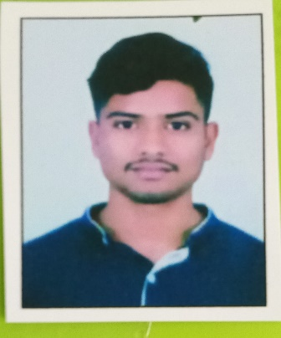

Himansu Parida

S/O-Dinabandhu Parida

At-Balabhadrapur,Po-Kusumbar,

Dist-Puri, Pin-752109, Odisha

Mob-9668304388

Email ID –paridahimansu82@gmail.com

***OBJECTIVE :***

Intend to build my career at an esteemed organization which would tell my knowledge, help to achieve my goals and to move ahead in this competitive world while being resourceful, innovative and flexible.

***EDUCATIONAL QUALIFICATION :***

* Persuing B.tech in Gandhi Institute of Excellent Technocrats in Bhubaneswar.
* Passed +2 Science from Regional Higher Secondary School,Nimapara in the year 2022
* Passed H.S.C from Surendranath Nodal High School,Sundar in the year 2020

***COMPUTER SKILLS :***

* Well versed with MS Word, Excel, Power Point, Outlook and Windows 2019.
* Completed core Java , HTML , CSS , C , DSA .

***PERSONAL TRAITS :***

* Self motivated with a positive attitude.
* The ability to work in a team.
* Adaptable to the changes in my surroundings.
* I take initiative to improving the things and convince others to join me.
* Interested in exploiting my theoretical knowledge as practical.

***EXPERIENCE :***

* Lab Assistance in Career Computer Academy,
* Making salesforce UI using HTML,CSS ,JAVASCRIPT
* Making tic tac game JAVA with DSA

***PERSONAL DETAILS :***

Name : HIMANSU PARIDA

Father’s Name : DINABANDHU PARIDA

Date of Birth : 11.03.2006

Marital Status : Unmarried

Languages Known : Oriya, Hindi & English,

Nationality : Indian

Religion : Hindu

Gender : Male

***DECLARATION :***

I consider myself fit and efficient for all type of situations and conditions. I am also confident of my ability to work in a team as I have proved it in my school, college and work field.

I hereby declare that the information furnished above is true to the best of my knowledge.

**Place: Puri**  ***Himansu Parida***